**ERD Model PART 3**

Illustrate that you understand normalization and how to use it to reduce uncontrolled redundancy in your database design by creating two ERD diagrams:

**Answer:**  In this reformation of the ERD diagram we find that redundancy from a connection or gathering of relations is limited through the course of normalization. Insertion, deletion, and update abnormalities could result from social overt repetitiveness. In this manner, it assists with lessening social overt redundancy. Redundancy in data set tables is eliminated or diminished utilizing typical structures.

By analyzing new information types used in the table, standardization assists with taking out intricacy and overt repetitiveness. The enormous data set table can be separated into more modest tables and associated through connections. It holds a table back from having copy information or rehashing gatherings

Create the first using UML and the Umlet free utility.

**Answer:**

.  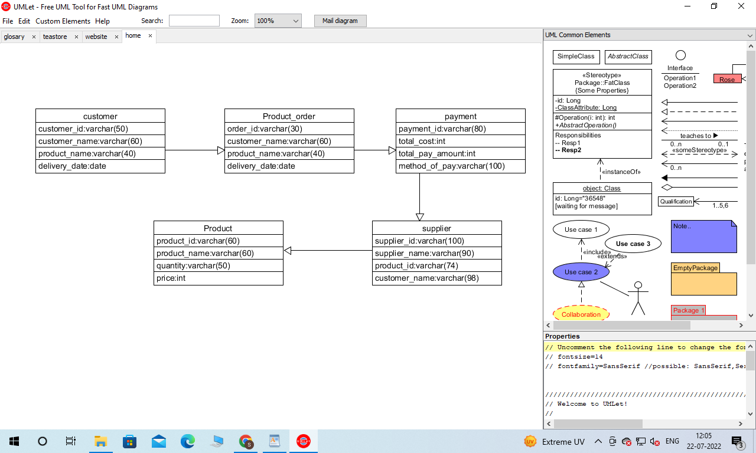

Create the second using Crow’s Foot notation in Vertabelo.

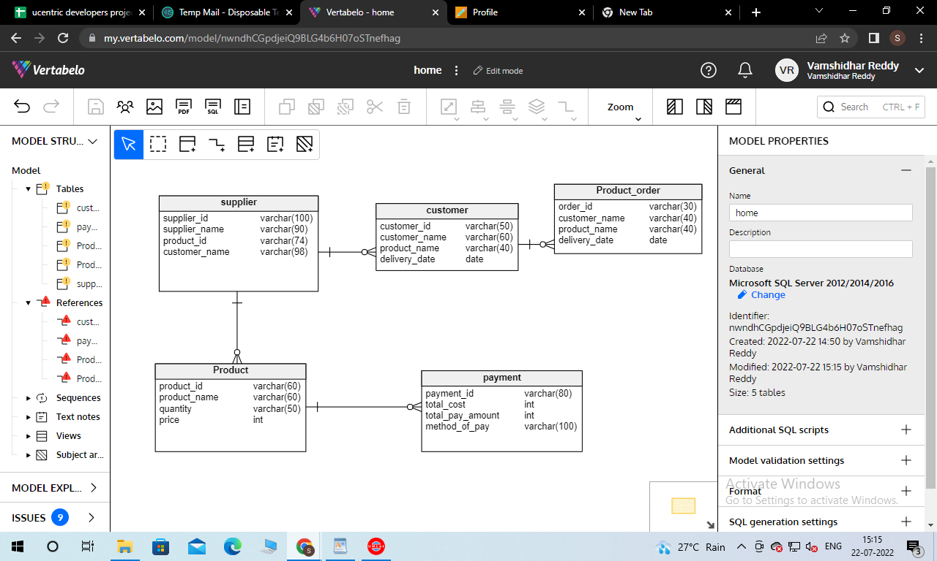

**Additional changes:**

**Description of relationship or arrows:**

For this particular business purpose we create an Entity relationship diagram in vertebelo. For this purpose we create 5 tables which are also connected to each other in an arrow entity relationship. Our first entity is a supplier which is connected to a customer entity and there has developed one to many relationship between them. There is one to many relationship between the Supplier entities and Product Entity. There we develop a one to many relationship between the customer entity with Product_order Entity. Our Product Entity table also connected through one to many relationships with payment Entity.